INDIFFERENCE CURVE

INTRODUCTION

The indifference curve is a geometrical device that has been used to replace the neo-classical cardinal utility concept. Prof. Hicks presented its comprehensive version in his Value and Capital in 1939 and its major revision in his A Revision of Demand Theory in 1956.

INDIFFERENCE CURVES

The indifference curve analysis measures utility ordinally. It explains consumer behaviour in terms of his preferences or rankings for different combinations of two goods, say X and Y. An indifferent curve is drawn from the indifference schedule of the consumer. The latter shows the various combinations of the two commodities such that the consumer is indifferent to those combinations. "An indifference schedule is a list of combinations of two commodities the list being so arranged that a consumer is indifferent to the combinations, preferring none of any other

ASSUMPTIONS OF INDIFFERENCE CURVE ANALYSIS

The indifference curve analysis retains some of the assumptions of the cardinal theory, rejects others and formulates its own. The assumptions of the ordinal theory are the following:

1)The consumer acts rationally so as to maximize satisfaction.

2) There are two goods X and Y.

3) The consumer possesses complete information about the prices of the goods in the market.

4)The prices of the two goods are given.

5)The consumer's tastes, habits and income remain the same throughout the analysis

6)He prefers more of X to less of Y or more of Y to less of X.
7)An Indifference curve is negatively inclined sloping downward.
8) An indifference curve is always convex to the origin.
(9) An indifference curve is smooth and continuous which means that the two goods are highly divisible and that levels of satisfaction also change in a continuous manner.

(10) The consumer arranges the two goods in a scale of preference which means that he has both `preference' and `indifference' for the goods.

(11 ) Both preference and indifference are transitive. It means that if combination A is preferable to B, and B to C; then A is preferable to C. Similarly, if the consumer is indifferent between combinations A and B, and B and C, then he is indifferent between A and C. This is an important assumption for making consistent choices among a large number of combinations.

12) The consumer is in a position to order all possible combinations of the two goods.

PROPERTIES OF INDIFFERENCE CURVES

From the assumptions described above the following properties of indifference curves can be deduced.

(I) A higher indifference curve to the right of another represents a higher level of satisfaction and preferable combination of the two goods.

In Figure 15.3, consider the indifference curves I₁, and I₂, and combinations N and A respectively on them. Since A is on a higher indifference curve and to the right of N, the consumer will be having more of both the goods X and Y. Even if the two points on these curves are on the same plane as M and A, the consumer will prefer the latter combination, because he will be having more of goods X though the quantity of goods Y is the same.
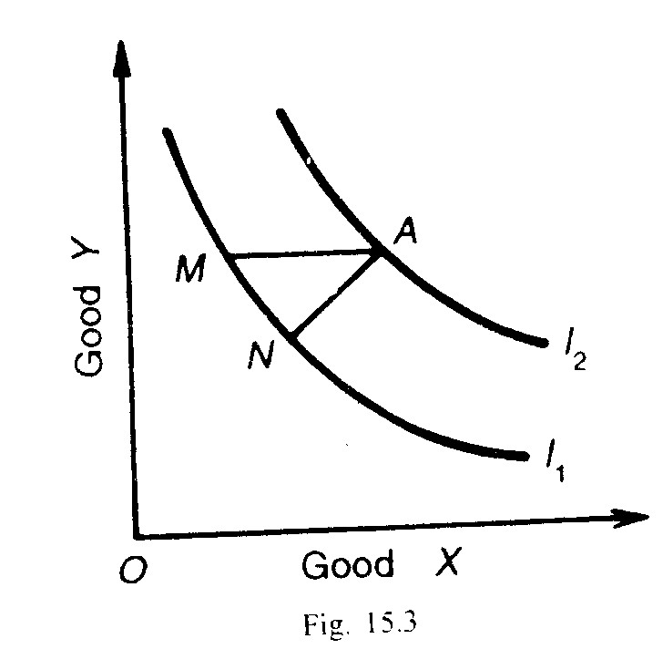

(2) In between two indifference curves there can be a number of other indifference curves, one for every point in the space on the diagram.

(3) The numbers I₁, I₂„ 1₃, I₄,....etc. given to indifference curves are absolutely arbitrary. Any numbers can be given to indifference curves. The numbers can be in the ascending order of 1, 2, 4, 6 or 1, 2, 3, 4, etc. Numbers have no importance in the indifference curve analysis.

(4) The slope of an indifference curve is negative, downward sloping, and from left to right- It means that the consumer to be indifferent to all the combinations on an indifference curve must leave less units of good Y in order to have more of good X. To prove this property, let us take indifference curves contrary to this assumption.
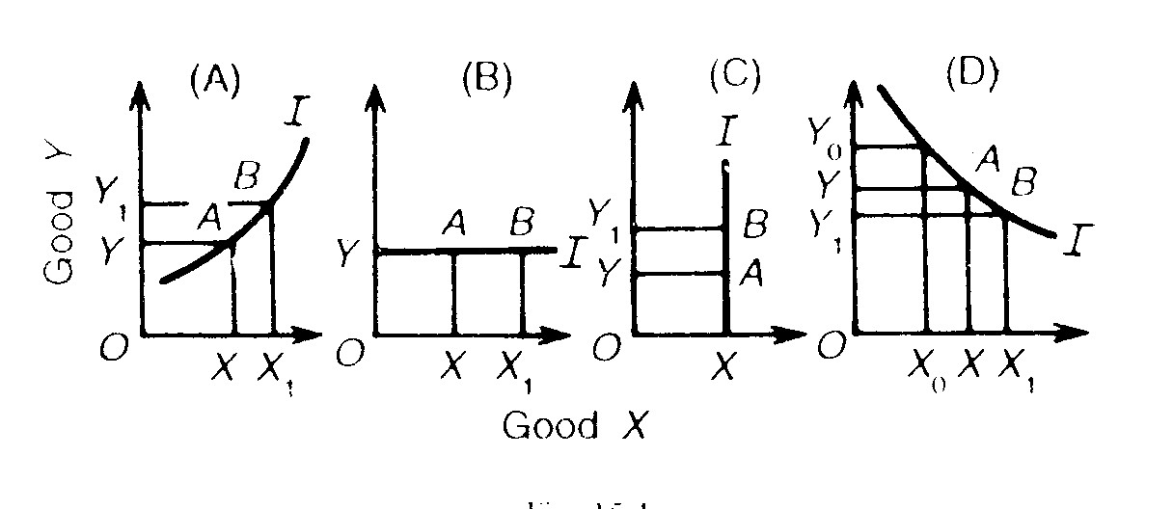
In above Figure (A) combination B is preferable to combination A which has a smaller mount of the two goods. Therefore an indifference Curve cannot slope upward from left to right.

Similarly, in Figure (B& C) combination B is preferable to combination A so indifference curve cannot be horizontal or vertical.

(5) Indifference curves can neither touch nor intersect each other so that one indifference curve passes through only one point on an indifference map.

What absurdity follows from such a situation can be shown with the help of Figure 15.5(A) where the two curves I₁ and I₂ cut each other. Point A on the I₁ curve indicates a higher level of satisfaction than point Bon the I₂, curve, as it lies farther away from the origin But point C which lies on both the curves yields the same level of satisfaction as point A and B. Thus
On the curve I₁: A = C ,and
on the curve I₂: B = C So A= B

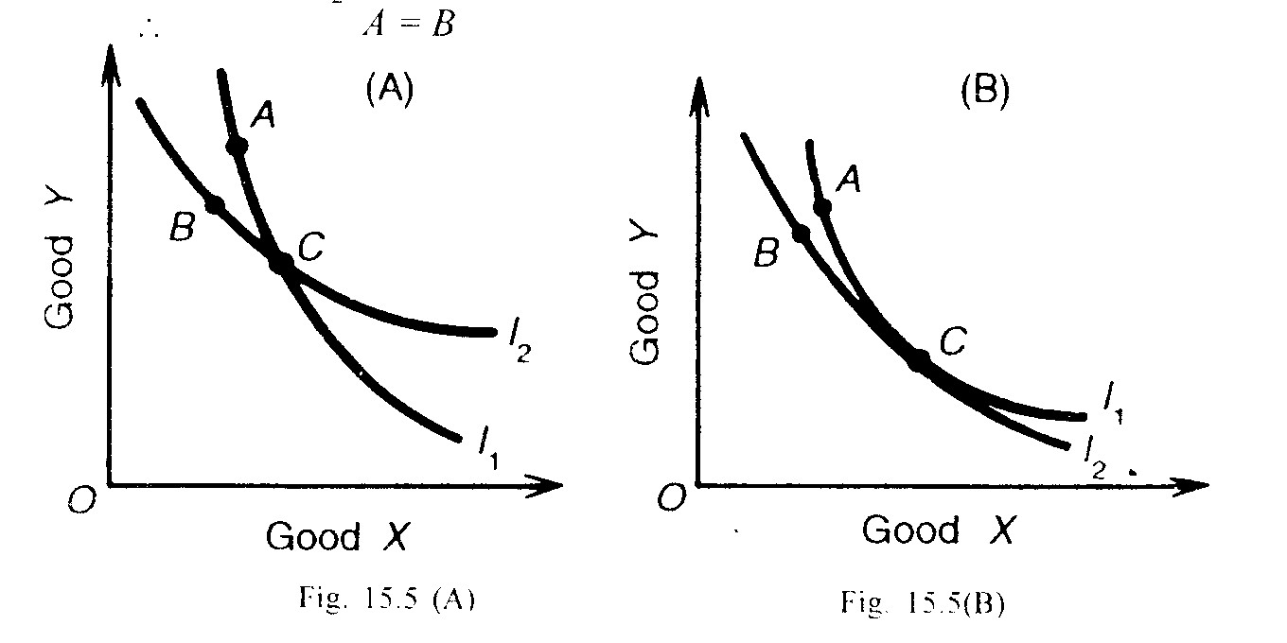

This is absurd because A is preferred to B, being on a higher indifference curve I₁. Since each indifference curve represents a different level of satisfaction, indifference curves can never intersect at any point. The same reasoning applies if two indifference curves touch each other at point C in Panel (B) of the figure.

(6) An indifference curve cannot touch either of the axis. If it touches X-axis as I₁, in Figure 15.6 at M, the consumer will be having OM quantity of good X and none of Y'. Similarly if an indifference curve I₂, touches the Y-axis at L, the consumer will have only OL of Y good and no amount of X. Such curves are in contradiction to the assumption that the consumer buys two goods in combinations.

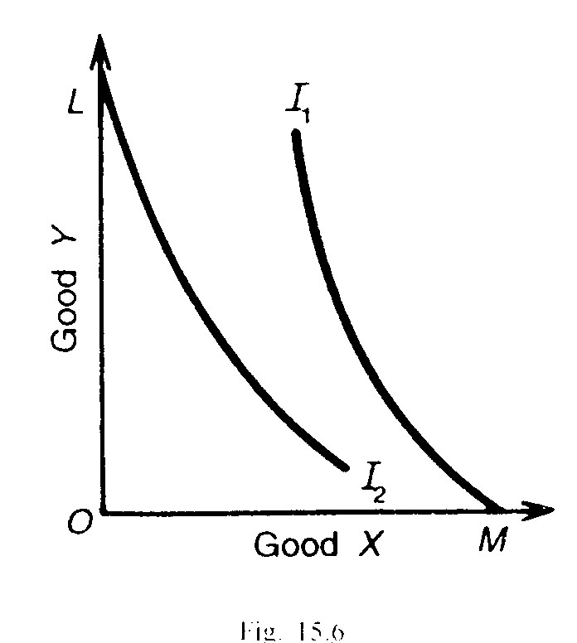
(7) An important property of indifference curves is that they are convex to the origin.

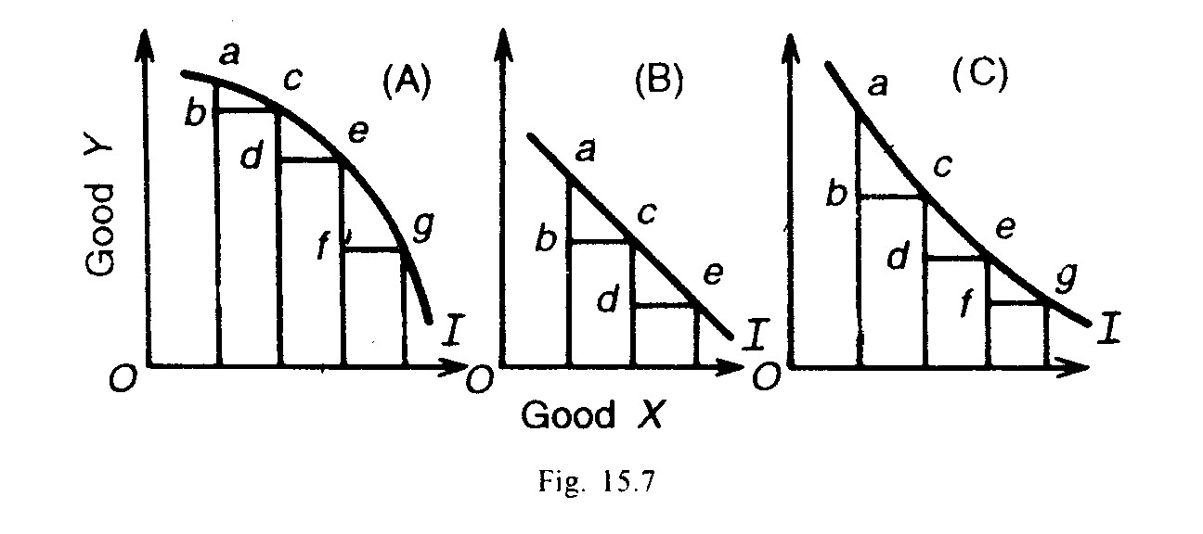
The convexity rule implies that as the consumer substitutes X' for Y, the marginal rate of substitution diminishes. To prove this, let us take a concave curve where the marginal rate of Substitution of X for Y increases instead of diminishing i.e., more of Y is given up to have additional units of X. As in Figure 15.7 (A), the consumer is giving up ab< cd<ef units of Y for bc= de=fg units of x. But an indifference curve cannot be concave to the origin.

If we take a straight line indifference curve at an angle of 45° with either axis, the marginal rate of substitution between the two goods will be constant, as in Panel (B) where ab of Y= bc of X and cd of Y= de of X. Thus an indifference curve cannot be a straight line.

Figure 15.7(C) shows the indifference curve as convex to the origin. Here the consumer is giving up less and less units of Y in order to have equal additional units of X i.e., ab> cd> ef of Y for bc= de=fg= of X. Thus an indifference curve is always convex to the origin because the marginal rate of substitution between the goods declines.

(8) Indifference curves are not necessarily parallel to each other.

Though they are falling negatively inclined to the right, yet the rate of fall will not be the same for all indifference curves. In other words, the diminishing marginal rate of substitution between the two goods is essentially not the same in the case of all indifference schedules. The two curves I₁,and I₂,shown in figure 15.8 are not parallel to each other.

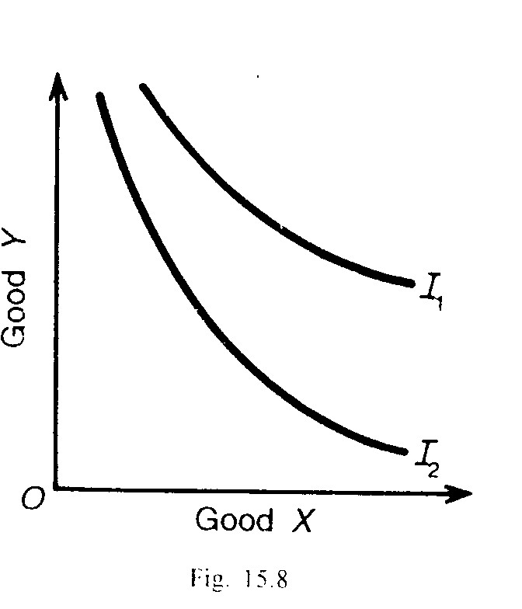
(9) In reality, indifference curves are like bangles. But as a matter of principle, their effective region in the form of segments is shown in figure 15.9. This is so because indifference curves are assumed to be negatively sloping and convex to the origin.

